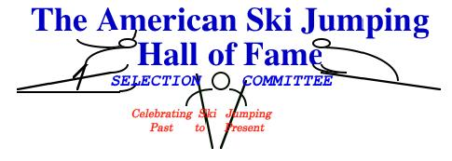
10 December 2014

To: All Ski Jumping Enthusiasts
From: Wally Wakefield, Chairman - ASJHF Selection Committee
About: 2015 Nominations

I am writing this note to all persons interested in the preservation of the heritage of jumping, and keeping our cherished memories alive.

The American Ski Jumping Hall of Fame (ASJHF) held the Eighth Annual Induction Ceremonies August 16, 2014, at the ASJHF Museum in the St. James Hotel, Red Wing, MN.

At this time I am asking for nominations for 2015 inductions.

Information about the ASJHF, along with criteria and the form for nominations, may be found online … www.americanskijumping.com. Click to the HOF page; the link to the nomination form is in the lower part of that page. You can print the form and fill it out, then return it by mail to my address, which is provided on the form.

Deadline for 2015 nominations is June 30, 2015.

Sincerely,

Wally Wakefield

Chairman - ASJHF Selection Committee

